FAST NUCES
Database Systems
Instructor: Mr. Talha Shahid
Project Report
CineMatch: Database Design and Integration for an AI-Powered Movie Recommendation System
Team Members
Name | ID
Tayaba | 24K-0934
Wardah Ahmed | 24K-1045

Note: This project is a combined submission integrating the Database Systems course with the Artificial Intelligence course. Humna Fatime (23K-1016) is part of the CineMatch AI team but does not take the Database Systems course and is therefore not included in this submission.
Submission Date: May 8, 2026

1. Project Overview
CineMatch is an AI-powered movie recommendation system originally developed as part of the Artificial Intelligence course. The system uses content-based filtering, collaborative filtering, SVD, and a hybrid recommendation algorithm to suggest personalized movies to users. For the Database Systems course, the project extended CineMatch by designing and implementing a proper relational database backend that replaces the flat-file data storage previously used.
The database stores all movie metadata, user information, ratings, genres, and interaction logs in a normalized relational schema. It was implemented using SQLite, with a design compatible with PostgreSQL for production deployment. The Python application interacts with the database using the built-in sqlite3 library, and all core queries are written in standard SQL. The full implementation was completed and tested end-to-end using the MovieLens 100K dataset.

2. Implemented Database Schema
The final database consists of six tables organized in a normalized relational structure. The schema is in Third Normal Form (3NF) to eliminate redundancy and ensure data integrity. The ER diagram is included in section 3.
2.1 Tables Overview
Table | Primary Key | Key Columns | Purpose
users | user_id | age, gender, occupation, zip_code | Stores user profiles from MovieLens
movies | movie_id | title, release_year, imdb_url | Stores movie information
genres | genre_id | genre_name | Lookup table for all 19 genre categories
movie_genres | movie_id + genre_id | movie_id (FK), genre_id (FK) | Many-to-many: movies to genres
ratings | rating_id | user_id (FK), movie_id (FK), score, rated_at | All user ratings on a scale of 1 to 5
interaction_logs | log_id | user_id (FK), query_movie, recommended_movies, created_at | Logs every recommendation request

2.2 Relationships
- One user → many ratings (one-to-many). This is the core relationship for collaborative filtering: the ratings table is the bridge between users and movies, and all similarity computations are derived from it.
- One movie → many ratings (one-to-many). Movies with fewer than a threshold number of ratings are treated as cold-start items; this count is directly queryable using GROUP BY and HAVING.
- Movies ↔ Genres (many-to-many, resolved via movie_genres). Separating genres into a lookup table eliminates the repeating binary-flag columns in the raw MovieLens CSV and brings the schema into 1NF.
- One user → many interaction logs (one-to-many). The interaction_logs table is the only persistent record of what the system actually recommended, which had no equivalent in the original flat-file implementation.
- Foreign key constraints use ON DELETE CASCADE. Removing a user automatically removes their ratings and interaction logs, preventing orphaned rows.

2.3 Indexing
Three indexes were created on the performance-critical ratings table (100,000 rows):
- idx_ratings_user_id on ratings(user_id)—supports user rating history lookups and collaborative filtering joins
- idx_ratings_movie_id on ratings(movie_id) — supports per-movie average rating queries
- idx_movie_genres_movie_id on movie_genres(movie_id) — supports genre-based filtering joins

3. ER Diagram
The Chen-notation ER diagram below shows four primary entities (USERS, MOVIES, GENRES, INTERACTION_LOGS) connected by three relationships: RATES (USERS–MOVIES, cardinality 1:N on the user side and 1:M on the movie side, with score and rated_at as relationship attributes), TAGGED WITH (MOVIES–GENRES, cardinality N:M resolved by the movie_genres junction table), and INITIATES (USERS–INTERACTION_LOGS, cardinality 1:N). The recommended_movies attribute on INTERACTION_LOGS is modeled as a multivalued attribute since a single log entry stores a comma-separated list of recommended titles.
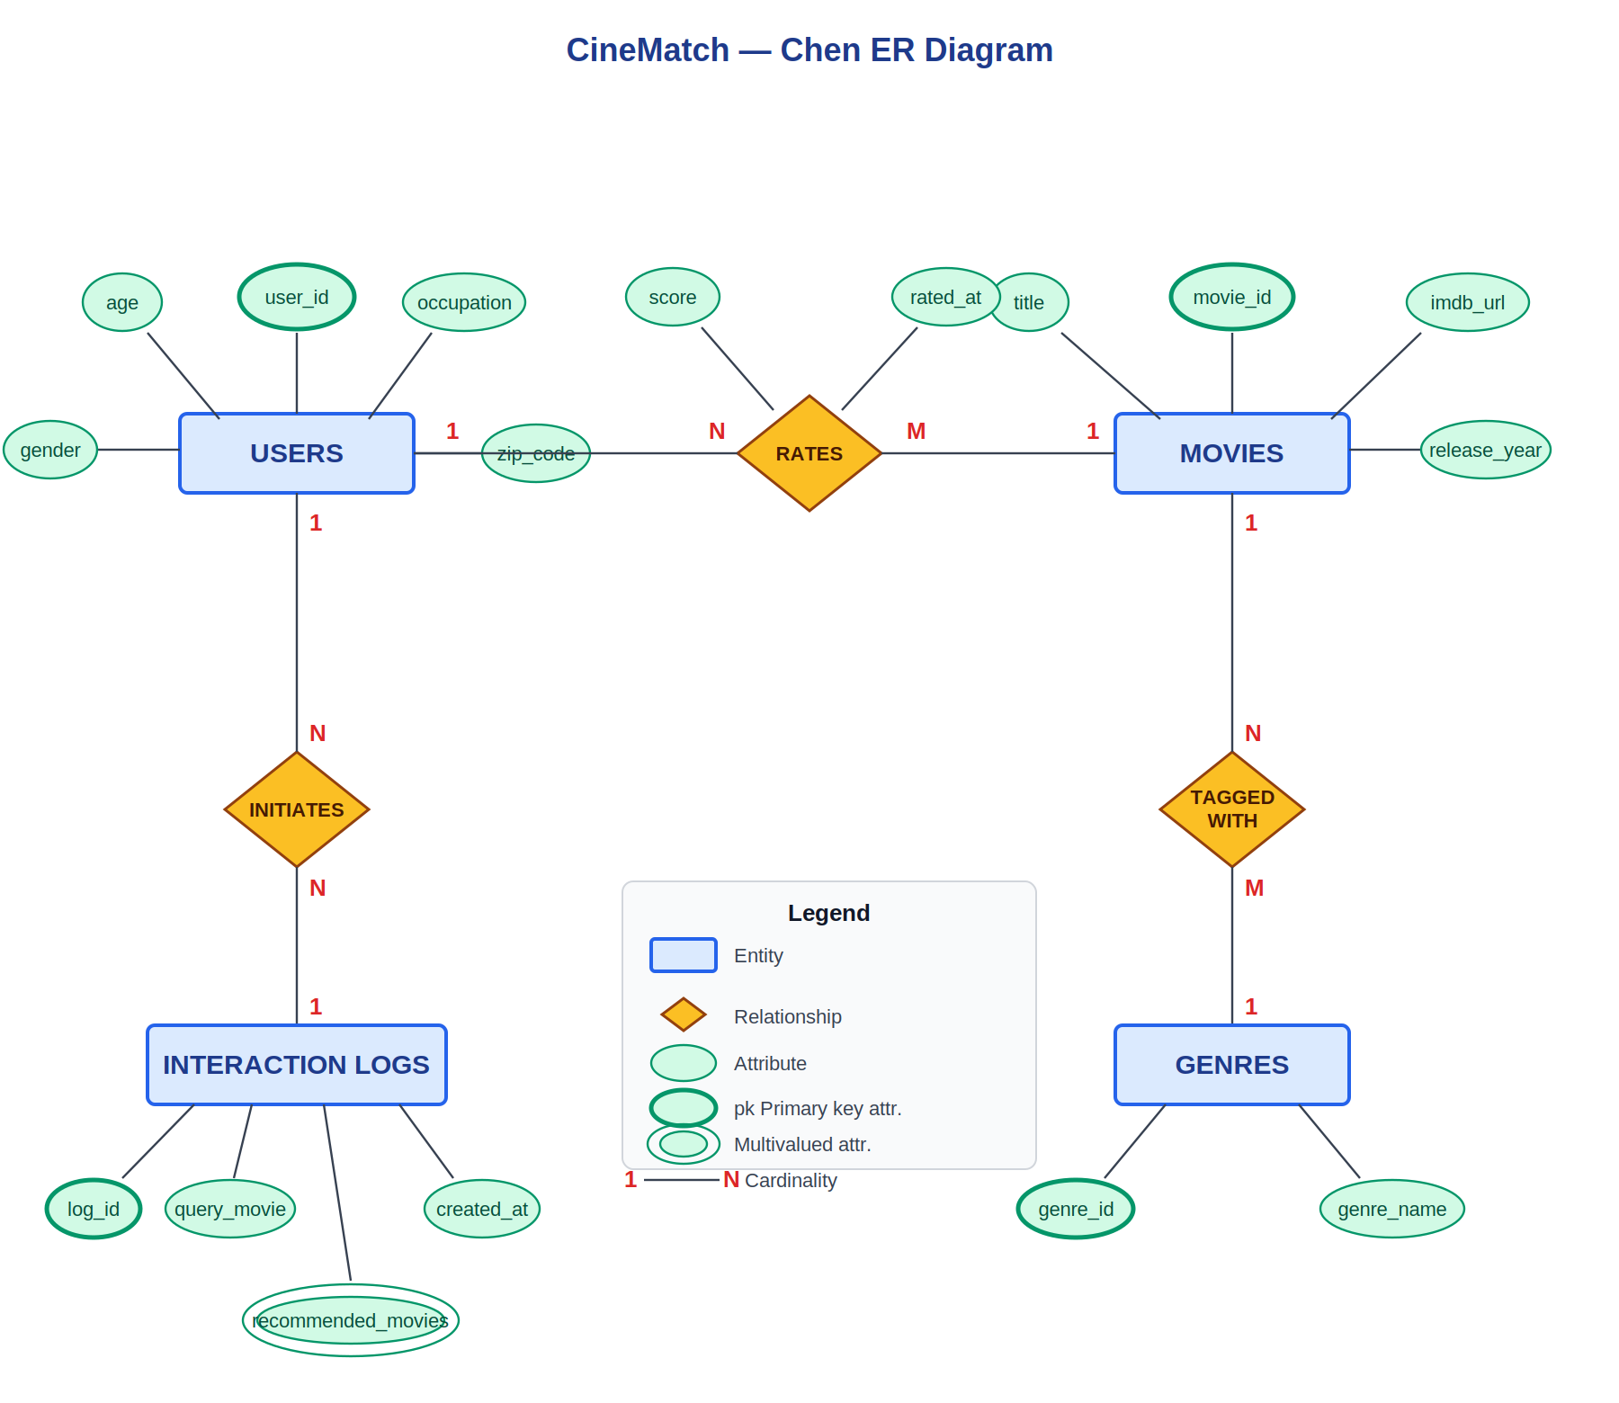
Figure 1: CineMatch Chen-Notation ER Diagram

4. Data Population
The database was populated from the MovieLens 100K dataset. Raw CSV files were read into pandas DataFrames and inserted using a combination of pandas to_sql and cursor.executemany. The movie_genres table was populated by iterating over the 19 binary genre flag columns in the movies CSV, mapping each flagged column to a (movie_id, genre_id) pair and inserting it into the junction table. Final row counts after population:
Table | Rows Inserted
users | 943
movies | 1,682
genres | 19
movie_genres | 2,893
ratings | 100,000
interaction_logs | 0 (populated at runtime)

5. SQL Queries and Results
5.1 Query Summary
# | Query | Concepts Used
1 | Top 10 highest rated movies (min 50 ratings) | JOIN, GROUP BY, HAVING, AVG, ORDER BY
2 | Rating history for a specific user | JOIN, WHERE, ORDER BY
3 | Genre-based movie search | JOIN, WHERE
4 | Top 10 most active users | JOIN, GROUP BY, COUNT, AVG, ORDER BY
5 | Genre popularity by movie count | JOIN, GROUP BY, COUNT, ORDER BY
6 | Average rating per genre | JOIN, GROUP BY, AVG, ORDER BY
7 | Cold-start recommendations for new users | GROUP BY, HAVING, AVG, ORDER BY
8 | Movies liked by users similar to a target user | Nested subqueries, JOIN, GROUP BY, COUNT

5.2 Selected Query Results
Query 1 — Top 10 Highest Rated Movies (minimum 50 ratings)
Title | Avg Rating | Total Ratings
Close Shave, A (1995) | 4.49 | 112
Wrong Trousers, The (1993) | 4.47 | 118
Schindler's List (1993) | 4.47 | 298
Casablanca (1942) | 4.46 | 243
Shawshank Redemption, The (1994) | 4.45 | 283
Wallace & Gromit: The Best of Aardman Animation (1996) | 4.45 | 67
Usual Suspects, The (1995) | 4.39 | 267
Rear Window (1954) | 4.39 | 209
Star Wars (1977) | 4.36 | 583
12 Angry Men (1957) | 4.34 | 125

Query 4 — Top 10 Most Active Users
User ID | Occupation | Total Ratings | Avg Rating
405 | healthcare | 737 | 1.83
655 | healthcare | 685 | 2.91
13 | educator | 636 | 3.10
450 | educator | 540 | 3.86
276 | student | 518 | 3.47
416 | student | 493 | 3.85
537 | engineer | 490 | 2.87
303 | student | 484 | 3.37
234 | retired | 480 | 3.12
393 | student | 448 | 3.34

Query 5 — Genre Popularity by Number of Movies
Genre | Movie Count
Drama | 725
Comedy | 505
Thriller | 251
Action | 251
Romance | 247
Adventure | 135
Childrens | 122
Crime | 109
SciFi | 101
Horror | 92

Query 6 — Average Rating by Genre
Genre | Avg Rating | Total Ratings
FilmNoir | 3.92 | 1,733
War | 3.82 | 9,398
Drama | 3.69 | 39,895
Documentary | 3.67 | 758
Mystery | 3.64 | 5,245
Crime | 3.63 | 8,055
Romance | 3.62 | 19,461
Comedy | 3.39 | 29,832
Horror | 3.29 | 5,317
Fantasy | 3.22 | 1,352

Query 7 — Cold-Start Recommendations (minimum 100 ratings)
Title | Avg Rating | Total Ratings
Close Shave, A (1995) | 4.49 | 112
Schindler's List (1993) | 4.47 | 298
Wrong Trousers, The (1993) | 4.47 | 118
Casablanca (1942) | 4.46 | 243
Shawshank Redemption, The (1994) | 4.45 | 283
Usual Suspects, The (1995) | 4.39 | 267
Rear Window (1954) | 4.39 | 209
Star Wars (1977) | 4.36 | 583
12 Angry Men (1957) | 4.34 | 125
Silence of the Lambs, The (1991) | 4.29 | 390

Query 8 — Movies Liked by Users Similar to User 1
Title | Liked by Similar Users | Avg Score
E.T. the Extra-Terrestrial (1982) | 25 | 4.56
One Flew Over the Cuckoo's Nest (1975) | 25 | 4.56
Schindler's List (1993) | 22 | 4.77
Casablanca (1942) | 22 | 4.68
Rear Window (1954) | 21 | 4.52
To Kill a Mockingbird (1962) | 20 | 4.55
Scream (1996) | 20 | 4.55
Gandhi (1982) | 20 | 4.35

6. Interaction Logging
The interaction_logs table was populated at runtime by logging a sample recommendation request. User 1 queried the system using Toy Story (1995) as the input movie. The five recommended movies recorded in the log were: Schindler's List (1993), Casablanca (1942), One Flew Over the Cuckoo's Nest (1975), E.T. the Extra-Terrestrial (1982), and Rear Window (1954). The log captured the user_id, query_movie, recommended_movies as a comma-separated string, and a created_at timestamp of 2026-05-08 11:23:51. This confirms that the interaction_logs table functions correctly as a persistent audit trail for recommendation events, replacing the complete absence of such logging in the original flat-file system.

7. Technology Stack
Component | Technology | Purpose
Database | SQLite 3 | Lightweight relational database, no server required
Production DB | PostgreSQL 14+ | Production-ready deployment option
Language | Python 3.13 | Database interaction and data population scripts
DB Library | sqlite3 (built-in) | Python interface for SQLite
Data Library | pandas, NumPy | CSV loading, DataFrame manipulation, bulk inserts
Data Source | MovieLens 100K | Source dataset for populating the database
ORM | None (raw SQL) | All queries written in standard SQL
Notebook | Jupyter (ipykernel) | Implementation and query demonstration environment
Integration | FastAPI + SQLite | Database connected to the CineMatch REST API

8. Frontend Features
The Streamlit frontend provides two user-facing features:
- Get Recommendations: the user enters a user ID (1-943) and selects a movie they like. The hybrid model returns 10 personalized recommendations the user has not seen, displayed as a poster grid with TMDB ratings.
- Find Similar Movies: the user selects any movie and receives 10 genre-similar movies. This is not personalized and returns the same results for the same input regardless of user ID.
- Movie posters and ratings are fetched from the TMDB API at query time using the movie title as a search query.

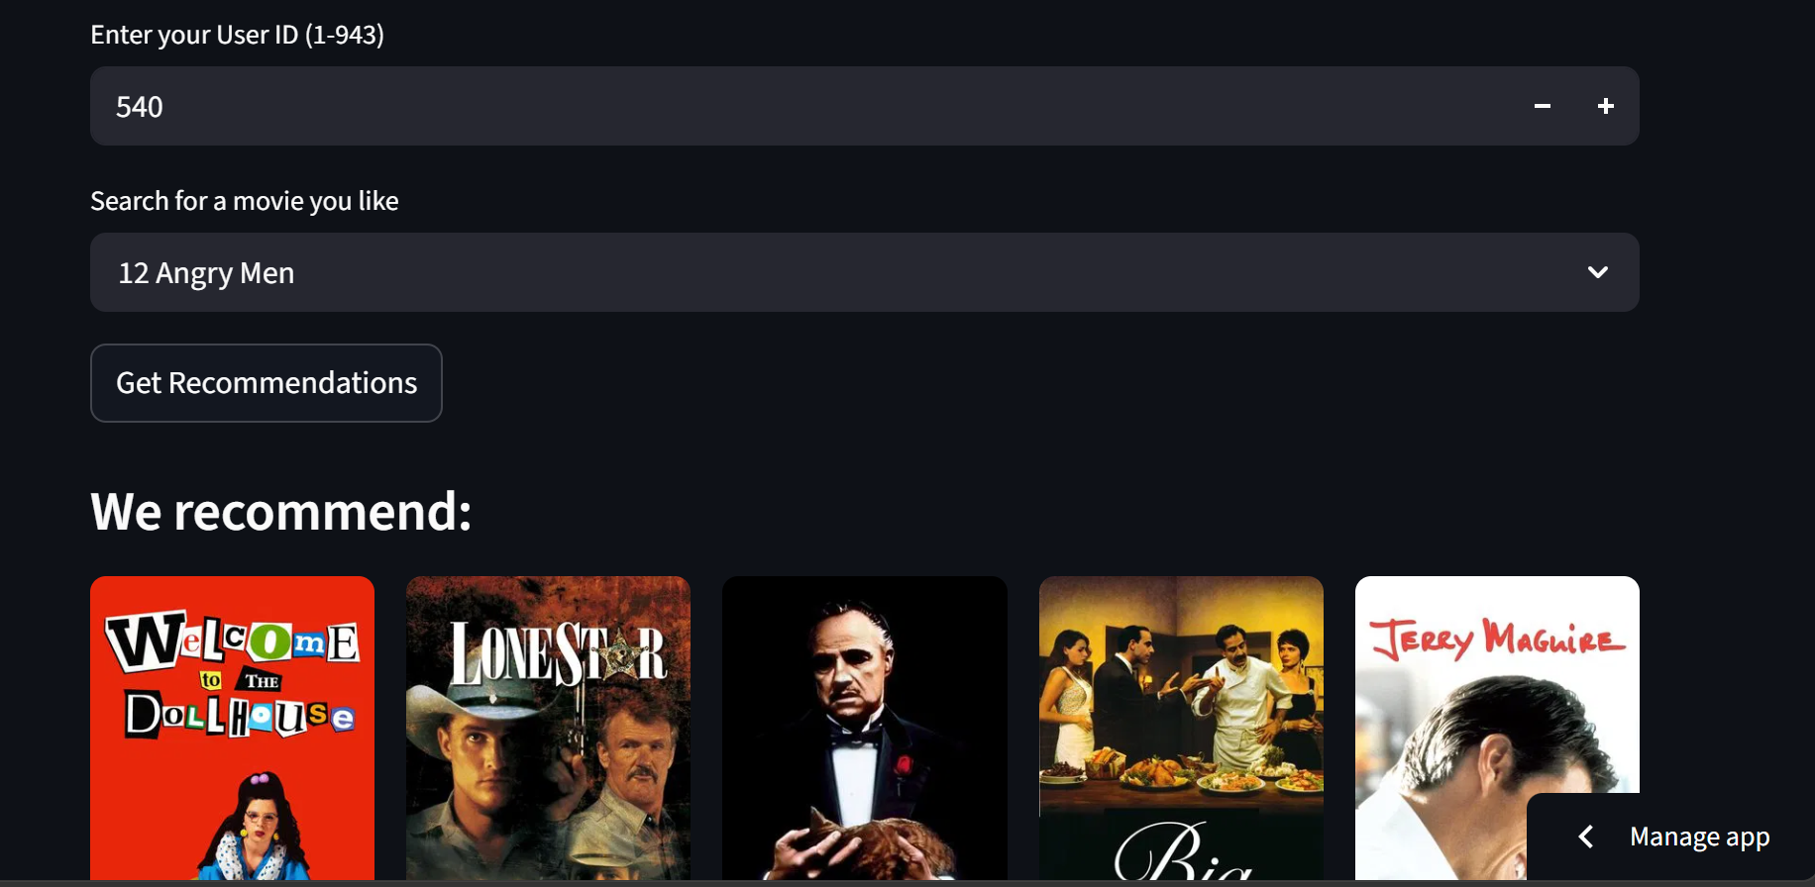
Figure 2: Get Recommendations Interface — User ID Input and Movie Selection
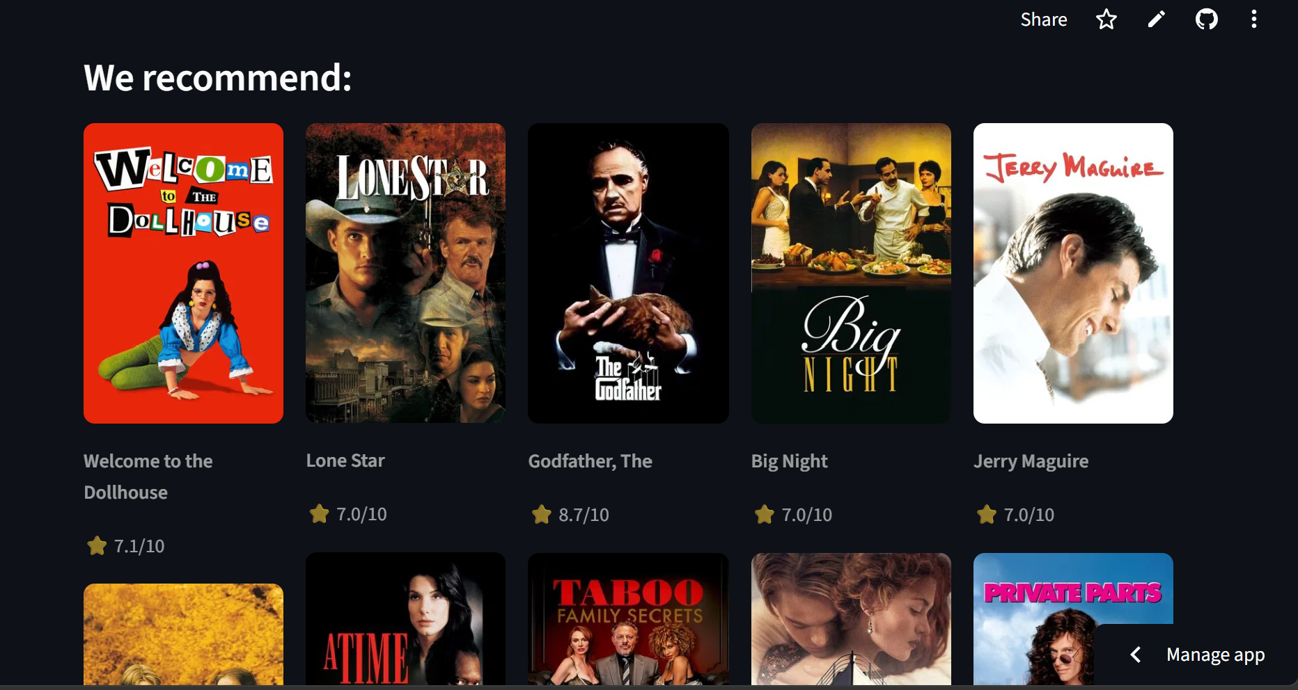
Figure 3: Personalized Recommendation Results Displayed as a Poster Grid with TMDB Ratings
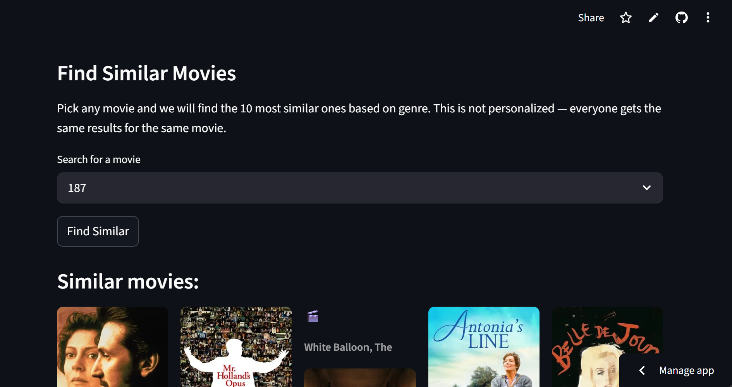
Figure 4: Find Similar Movies Interface — Genre-Based Search (Not Personalized)
9. Key Observations
The data population step revealed several details about the MovieLens dataset not visible when loading from CSV. Drama is the most represented genre at 725 movies, more than double Comedy at 505. Genre popularity by movie count does not mirror quality: Film Noir has the highest average rating at 3.92 despite covering only 24 movies, while Comedy ranks near the bottom at 3.39. User 405 is the most active user with 737 ratings but holds the lowest average of 1.83 among the top ten, suggesting systematically low scoring. The cold-start query at 100 minimum ratings produced a more trusted list than the top-rated query at 50, with Schindler's List, Casablanca, and Shawshank Redemption appearing in both.

10. Conclusion
The CineMatch database was successfully designed, implemented, and populated from the MovieLens 100K dataset. The six-table normalized schema correctly captures all entities and relationships required by the hybrid recommendation system. All eight SQL queries executed correctly and returned meaningful, verifiable results. The interaction logging system was demonstrated end-to-end by recording a live recommendation request. The database layer provides persistent structured storage that the original CSV-based system entirely lacked, enabling SQL queries over 100,000 ratings without loading full matrices into memory and maintaining a durable log of every recommendation event. Future work would replace the in-memory matrix lookups in the FastAPI routes with direct SQL queries, completing the full database-backed deployment described in the project proposal.

